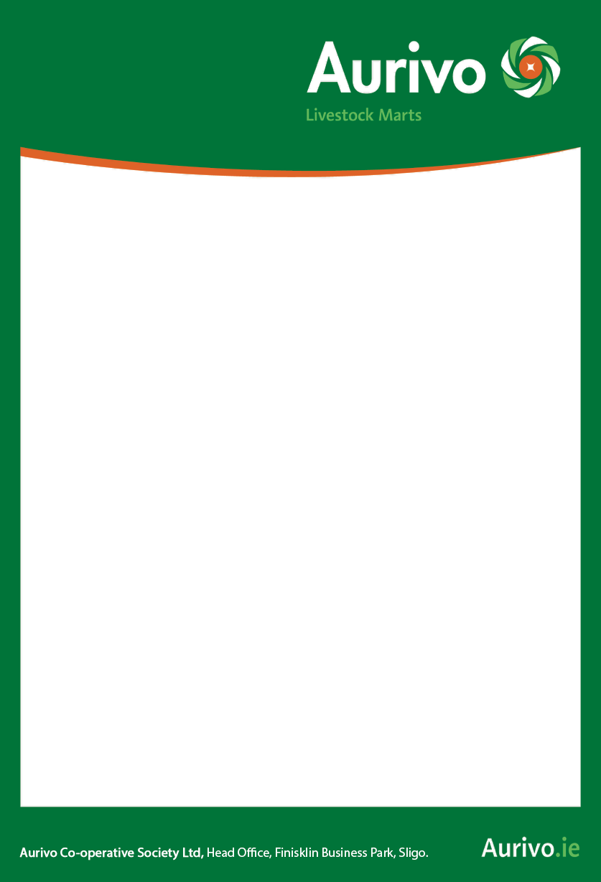

**BALLA MART**

**Special**

**Breeding Heifer Sale**

**Saturday October 23rd.**

**End of Month**

**Continental Sale**

**Saturday October 30th.**

**Booking as usual Wednesday on 0818-301-401**

NOTICE

NOTICE