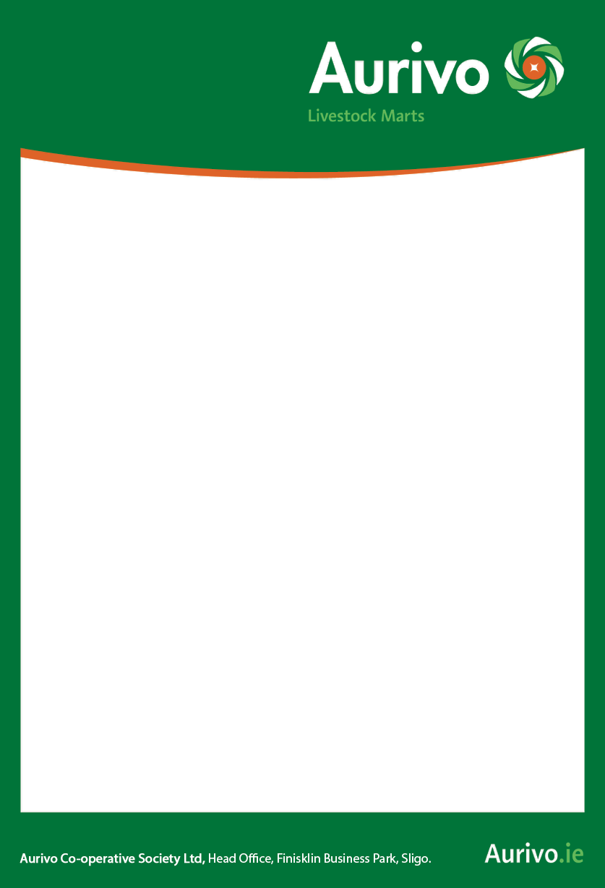

**End**

**Of Month**

**Continental Sale**

**Next Saturday**

**June 26th ‘21**

**Booking**

**0818 301 401**

**BALLA MART**

**Tel: 094-9365068**

**For Sale at Balla Mart**

**25 Lim & Simm 1st calf heifers.**

**Calving November & December**

**to easy calving AI Bulls.**

**All Top Quality Genuine Stock**

**Done for lepto and BVD.**

Prizes for the Best Bullock/Heifer per 100 kg on the day

Pre-booking every Wednesday from

9.30 am –1.00 pm for Saturday Sale

on 0818 301 401

2015/16 Licence in place